

UNDERGRADUATE PROJECT PROPOSAL

|  |  |
| --- | --- |
| **Project Title:** | An intelligence recommendation system for online food ordering platform based on Collaborative Filtering |
| **Surname:** | **Quan** |
| **First Name:** | **zhihao** |
| **Student Number:** | **202018010410** |
| **Supervisor Name:** | **Monty Mu** |
| **Module Code:** | **CHC 6096** |
| **Module Name:** | **Project** |
| **Date Submitted:** | **2023/11/3** |

**Table of Contents**

1 Introduction 3

1.1 Background 3

1.2 Aim 3

1.3 Objectives 3

1.4 Project Overview 4

1.4.1 Scope 4

1.4.2 Audience 4

2 Background Review 4

3 Methodology 6

3.1 Approach 6

3.1.1 Software development model: 6

3.1.2 Requirement collect method: 7

3.1.3 Test and evaluation: 8

3.2 Technology 8

3.3 Version management plan 9

4 Project Management 9

4.1 Activities 9

4.2 Schedule 9

4.3 Data management plan 9

4.4 Project Deliverables 10

5 References 10

# Introduction

## Background

In the era of highly developed information technology and logistics industry, online food delivery has become a new trend sweeping the world [1]. In online food platform, customers can browse menus, place orders, and pay for meals via websites or mobile applications.

However, the increasing health consciousness of consumers and their growing demand for healthy and sustainable food options has become a major trend in the online food delivery market. As a result, online food delivery platforms need to respond by offering a wider range of healthy and sustainable food choices. [1] However, too many kinds of products will make it difficult for users to find the information they like. Over time, user interest in the platform will decrease. [2]

Therefore, in order to solve the problem of information overload, recommend system are needed to help customer to find suitable products easily.[2] This project use an intelligent recommendation system based on collaborative filtering can provide personalized recommendations to customers, leading to a better user experience and augment customer satisfaction. Collaborative filtering is a type of recommendation algorithm that uses data to predict preferences and make recommendations. [2]

## Aim

The aim of this project is to develop an online food ordering platform featuring a collaborative filtering recommendation system that recommend foods based on user.

## Objectives

The object are as follows:

1. Research on existing recommendation system algorithm.
2. Analyze the function of online ordering platform.
3. Compare and choose the suitable recommendation system algorithm for website.
4. Develop the function and module design of the system.
5. Implement the basic function of the online food ordering website.
6. Collect data from multiple sources.
7. Build a user-friendly product recommendation system model.
8. Implement and improve the UI of the website.
9. Testing all modules and documenting and analyzing the performance of the recommended systems.

## Project Overview

### Scope

With the rapid development of the Internet and the increasing demand for food diversification, there are more and more types of food in the online ordering software. In order to improve the efficiency of consumers' search, this Online Food Ordering and Delivery Platform with Recommendation System, which can allow customer to browse, search and order the foods and pay the orders online, and also recommend foods or restaurants to customer based on the customer’s interests. For restaurant owner, they can view their order information and customer information on the system.

### Audience

This is an online ordering system, which means the main audience is restaurant merchants and customers. For customers, the system can provide them with personalized recommended food, reducing the selection difficulty and time cost. For restaurant owner, the system can more accurately show the foods and promotions to potential customer, and also can recommend foods suitable for users based on their preferences and historical order data, helping restaurants attract more satisfied customers.

# Background Review

Online food ordering platforms have become increasingly popular in recent years, revolutionizing the way customers order food and receive delivery. Several companies, including Meituan, Ele. me and Uber eats, are commercial giants in the food delivery platform space, with Meituan and Ele.me being the most used delivery software in China [3]. These platforms have transformed the food industry, providing consumers with an easy and convenient way to order food online.

Therefore, in order to analyze and investigate the characteristics of Online food ordering platforms, Table 1 below shows some functional comparisons of the three platforms. Through comparison, it is found that the basic functions of search, recommendation, purchase, shopping cart and order management are well implemented on the three platforms, while the payment methods are different due to different countries. It is worth noting that Uber eats performs better than the other two software in terms of Delivery Method and schedule.

|  |  |  |  |
| --- | --- | --- | --- |
| Feature Comparison | MeiTuan food delivery [4] | Ele.ME [5] | Uber eats [6] |
| Register required Information | **Phone number** | **Phone number** | **Email &**  **Phone number** |
| Shopping Cart | **YES** | **YES** | **YES** |
| Search restaurants | **YES** | **YES** | **YSE** |
| Search foods in restaurant page | **YES** | **YES** | **NO** |
| Favorite function | **YES** | **YES** | **YES** |
| Modify personal information | **YES** | **YES** | **YES** |
| Delivery Method | **Delivery** | **Delivery** | **Delivery & Pickup** |
| Schedule pickup | **NO** | **NO** | **YES** |
| Recommended  Restaurants | **YES** | **YES** | **YES** |
| Address Management | **YES** | **YES** | **YES** |
| Order view | **YES** | **YES** | **YES** |
| Payment method | **Alipay, Wechat payment, Meitun payment** | **Alipay, Wechat payment, China unionpay** | **Paypal, Cash, Credit card** |
| Customer rating function | **YES** | **YES** | **YES** |

Table 1: Feature comparison between different platforms

The success of these online food ordering platforms is largely due to their ability to provide personalized recommendations to users. Therefore, recommender systems play an important role in the e-commerce environment. Although a variety of recommendation technologies have appeared in recent years, collaborative filtering (CF) is a widely used algorithm in recommender systems, and is widely used in product recommendation and other fields.[7] CF can be divided into two categories according to the object of analysis: item-based recommendation or user-based recommendation.[8]

Therefore, in this project, collaborative filtering based on user recommendation is implemented, which predicts the most relevant items or services by analyzing the user's preference and behavior data (such as ratings, favorites and other behaviors).

# Methodology

## Approach

### Software development model:

In the choice of software development model, the waterfall model is a common and classic development model, which shows the software development process in linear order. As shown in Figure 1 below, the software development process can be divided into seven parts in linear order: Requirement Analysis, System design, Model selection, Implement the system, system integration, test, system operation and maintenance.

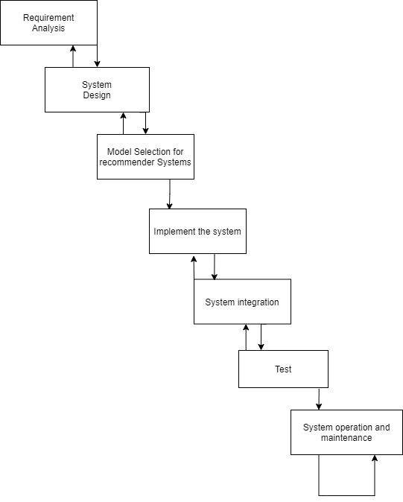

Figure 1: Waterfall model

### Requirement collect method:

* Market research: Utilize websites like statista to study the relevant market and competitors to understand the needs and preferences of users across the market. Relevant information can be obtained by investigating industry reports, data from market research agencies, and product analysis from competitors.
* User observation: Observe the behaviors and interactions of friends and classmates around when using the online takeout platform, so as to obtain the needs and problems of users in actual usage scenarios.
* Analysis for competitive products: Observe the popular online ordering software (Meituan, Ele.me, uber eats etc.) recorded to analyze which requirements are the most needed by users.

### Test and evaluation:

* **Functional**:

Unit tests: Test the independence and correctness of each functional module to ensure that the module works as expected.

Integration test: Test the cooperation between the various functional modules to ensure that the overall system functions normally.

Scenario test: Based on the actual use scenario, test the function and logic of the whole system to verify whether it meets the needs of users.

* **Recommendation system**:

Personalization evaluation: Tests whether the recommender system can provide personalized recommendation services according to the interests and preferences of users.

Product diversity evaluation: To test whether the recommendation system can provide diversified recommendation product and avoid excessive preference for specific types of recommendations.

* **Non-functional:**

Security testing: Evaluates the security of the system, including tests on data encryption, user authentication, and access control.

Performance test: By simulating different load and pressure conditions, the response time and other performance indicators of the system are tested.

## Technology

**Hardware**:

* Computer: ASUS Tianxuan
* CPU: R7-4800H
* Random Access Memory: 16GB

**Software:**

* Language: Python, Javascript
* IDE: Pychram
* Database: Mysql 8.0, Mysql workbench, Navicat
* Backend framework: Django
* UI: Javascript, Html, Css, JQuey, Bootstrap
* Operating system: windows 10

## Version management plan

State your plan of how you intend to use resources such as, e.g., Git repository or shared drive to manage the several versions of **your project code or developed software**.

# Project Management

## Activities

1. Investigation on the Existing Food Delivery Platform
2. Comparison between food delivery platform
3. Research on Collaborative Filtering (CF)
4. Determine a feasible recommender system model
5. Project proposal
6. Requirement analysis
7. System design (Split the system into modules)
8. Implementation
9. Implement the recommend function
10. Test and evaluate the recommend function
11. System testing
12. Final report
13. Create Poster

## Schedule

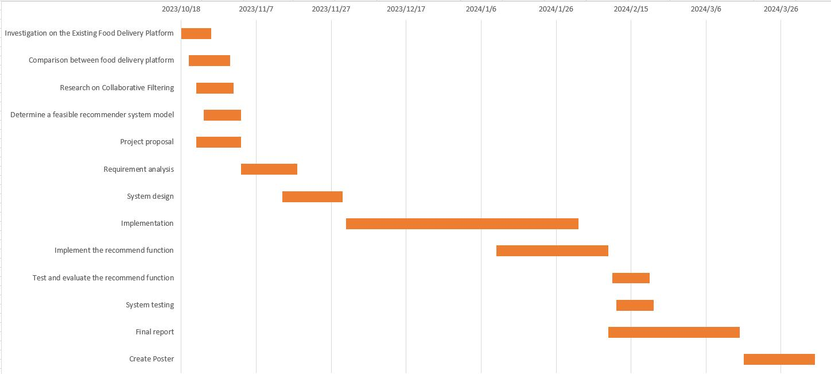

Figure 2: Gantt chart

## Data management plan

In this section, students must describe how they would use resources such as Baidu drive, Gitee, etc., to manage project logs, reports, literature, etc.

## Project Deliverables

In this section, briefly list all the documents and project resources that must be submitted for assessment. Example: Project proposal, progress report, final report, project code/ software, etc.

# References

[1] Statista Market Insights, ‘Online Food Delivery: market data & analysis’, Statista Market Insights, Mar. 2023. Accessed: Oct. 30, 2023. [Online]. Available: https://www.statista.com/study/40457/food-delivery/

[2] X. Li, ‘Research on the Application of Collaborative Filtering Algorithm in Mobile E-Commerce Recommendation System’, in *2021 IEEE Asia-Pacific Conference on Image Processing, Electronics and Computers (IPEC)*, Dalian, China: IEEE, Apr. 2021, pp. 924–926. doi: 10.1109/IPEC51340.2021.9421092.

[3] Statista, ‘Catering-services-in-china’, Statista. Accessed: Nov. 01, 2023. [Online]. Available: https://www.statista.com/study/63164/catering-services-in-china/

[4] ‘Meituan Waimai’. Meituan. [Online]. Available: https://waimai.meituan.com/. Accessed on: Oct. 31, 2023.

[5] ‘Ele.me’. Ele.me. [Online]. Available: https://www.ele.me/. Accessed on: Oct. 31, 2023.

[6] ‘Uber Eats’. Uber Eats. [Online]. Available: https://www.ubereats.com. Accessed on: Oct. 31, 2023.

[7] X. Zhu, H. Ye, and S. Gong, ‘A personalized recommendation system combining case-based reasoning and user-based collaborative filtering’, in *2009 Chinese Control and Decision Conference*, Jun. 2009, pp. 4026–4028. doi: 10.1109/CCDC.2009.5192712.

[8] H. Liu, ‘Implementation and Effectiveness Evaluation of Four Common Algorithms of Recommendation Systems - User Collaboration Filter, Item-based Collaborative Filtering, Matrix Factorization and Neural Collaborative Filtering’, in *2022 International Conference on Cloud Computing, Big Data Applications and Software Engineering (CBASE)*, Sep. 2022, pp. 224–227. doi: 10.1109/CBASE57816.2022.00049.